Summary test report

by Mariia Mielnikova

based on

test cases for Alpha-testing

by Max Shylov

*Review Date: 03.05.2024*

*Project name: mobile app SKYBOT*

**Step #1) Purpose of the document**

This document explains a summary report based on test cases for Alpha-testing performed as part of the testing process of the mobile application “SKYBOT”, which is a mobile version of the online store that was developed and tested by our team earlier.

**Step #2) Mobile application “SKYBOT” overview**

B2C mobile app for a company that sells and services electric vehicles under the brand name SKYBOT. Application offers a different kind of activities which potential clients will appreciate - shop, members community groups, videos, registration on services appointments.

Application is available on popular mobile stores, such as Apple Store and PlayMarket.

**Step #3) Testing Scope**

A functionality verification of this mobile app will be presented by different kinds of functional and non-functional test cases, which were created earlier by the test owner and will show coverage of the main function and its possibilities.

***Areas covered:***

* Downloading and Launching
* Registration and Login
* Navigation
* Connection to the Internet
* Localization testing
* Interruption Testing
* Battery Drain Testing

***Areas not covered:***

* Profile functions
* Chat with Users
* Reviews section and Rating option
* Cart functionality

**Step #4) Test summary**

* Downloading, Launching and Deleting

These bunch of test cases show the correct and acceptable work of future application. We can be sure that application SKYBOT will not negatively affect to different mobile devices. The Application could be downloaded from the stores and could be deleted from the mobile device without any errors.

* Registration and Login

Test cases show an ability to register and log in the application. Users could choose different types of ways to register (Facebook, Google account and email). All tests have positive results, which means non problematic ability to become a new User.

* Navigation

Navigation tests confirm that Users will not have any difficulties during navigation through the SKYBOT mobile application. App is intuitive, clear and simple. Almost all tabs are open without delays and errors (tabs Schedule and Services are still developed)

* Connection to the Internet (mobile and WiFi spots)

Test owner has been testing application behavior during stable Internet connection, using two different ways to connect (mobile Internet 4G and WiFi connection). These tests allow us to see proper and stable performance of the application.

* Localization testing

One of the main group of the tests were performed by the test owner to estimate the correctness of the language in the application. According to the requirements all application should be in English. Tests show 95% of positive results.

* Interruption testing

These types of tests present a proper response of the application to external factors, such as phone calls, SMS or system reboot situations. Application acts in accordance with the conceived logic.

* Battery drain testing

This group of tests shows that application SKYBOT does not negatively affect battery health. Battery temperature remains stable and does not exceed critical levels.

**Step #5) Metrics**

| **Tests performed** | **Tests passed** | **Tests failed** |
| --- | --- | --- |
| **37** | **27** | **10** |

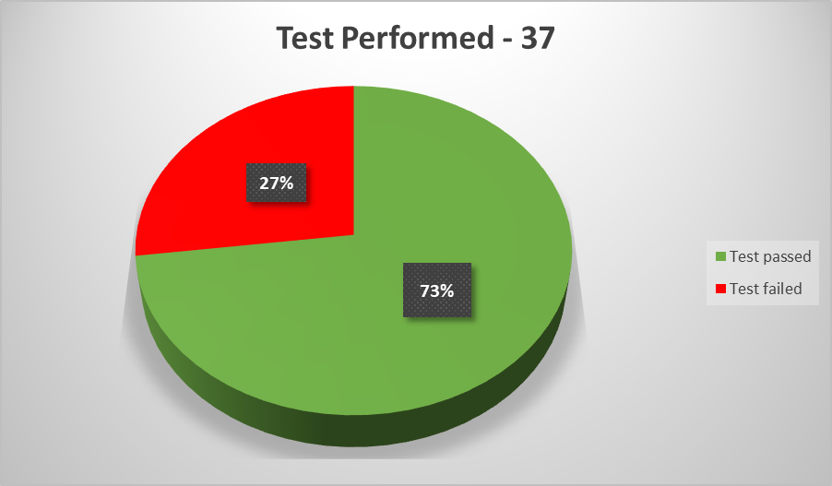

**Step #6) Environment**

**Samsung Galaxy A54,**

**Android 14, One UI 6.0**

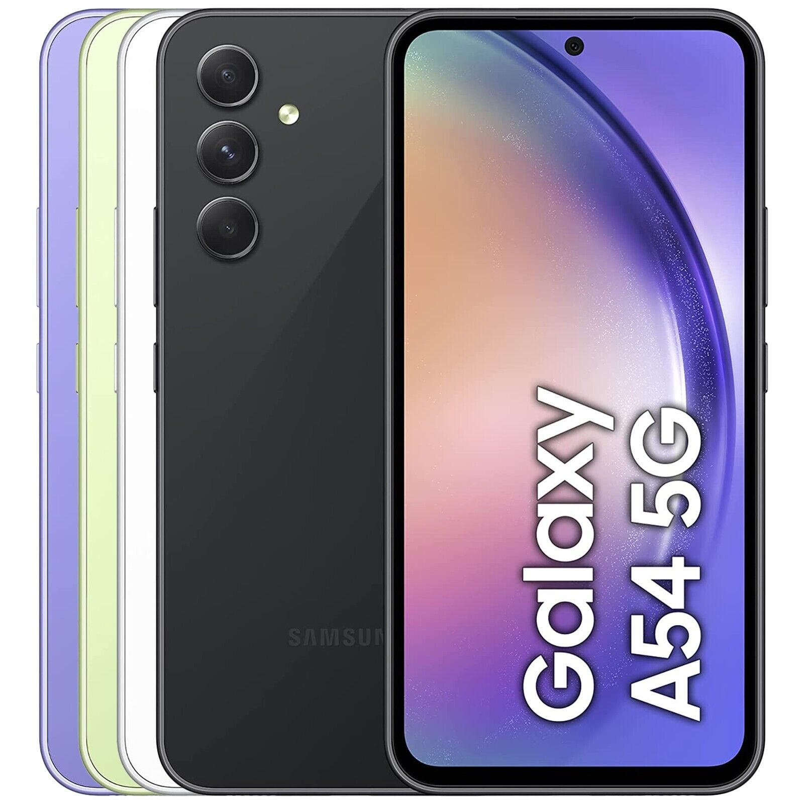

**Step #7) Recommendations**

I kindly recommend to include test cases for several critical section:

* Profile activities (profile visibility, managing photo, followers option)
* Communication with other Members (chat option is one of the important section which Users could use constantly)
* Reviews section (according to the customer's requirements, this element is essential for the functioning of the entire application and how it is seen by the potential user)
* Cart functionality (for better interaction between the user and the shopping cart, you need to add tests to test the promo code and the application's response on it)

**Step #8) Exit criteria**

* All test cases that were planned are executed
* Any other open issues have an action planned and are targeted for the next release cycle.

**Step #9) Conclusion**

*The mobile application SKYBOT was tested at a good level, which is confirmed by tests. It is recommended that some sections and details be finalized by developers and tested again. Appropriate User/Business acceptance testing should be performed before ‘Go Live’.*

**Step #10) Sign Off**

***Verified by Mariia Mielnikova***